**GURU JAMBHESHWAR UNIVERSITY OF SCIENCE AND TECHNOLOGY**

# **(Hisar-Haryana)**



**DEPARTMENT OF COMPUTER SCIENCE AND ENGINEERING**

**Practical file**

**Machine Learning**

**(PCC-CSEAI301-P)**

|  |  |
| --- | --- |
| **Submitted to :** | **Submitted by :** |
| **Dr. Narender**  **Dept. of CSE** | **Sarita**  **220010150027**  **B.Tech CSE- AI & ML** |

**INDEX**

|  |  |  |  |  |
| --- | --- | --- | --- | --- |
| **S.No.** | **Name of practical** | **Date** | **Page no.** | **Teacher’s sign** |
| 1. | Assignment demonstrating Linear Regression:  a) Implementing linear regression on placement dataset and predicting  the dependent  variable  b) Implementing linear regression on randomly generated dataset  and evaluation of the regression model using R2 score. | 09/08/24  09/08/24 | 1-2  3-4 |  |
| 2. | Implementing  and demonstrating  the Find-S algorithm for finding most specific hypothesis  using. | 23/08/24 | 5 |  |
| 3. | Implementing Candidate Elimination algorithm and finding specific and general boundary sets of hypotheses consistent with EnjoySport dataset. | 30/08/24 | 6-7 |  |
| 4. | Implementing  Perceptron learning from scratch and showing decision boundary. | 11/10/24 | 8-9 |  |
| 5. | Implementing classification using SVM :   1. For iris dataset using SVC default settings. 2. For recognition of handwritten digits. | 25/10/24 | 10-11  12-13 |  |
| 6. | Implement Naïve Bayes Classifier. | 25/10/24 | 14-17 |  |
| 7. | Implementing PCA on Iris Dataset and reducing 4D data into 2D using PCA. | 25/10/24 | 18-21 |  |
| 8. | Implement Gradient Descent algorithm. |  | 22-23 |  |

**1. Assignment demonstrating Linear Regression:**

**a) Implementing linear regression on placement dataset and predicting the dependent variable.**

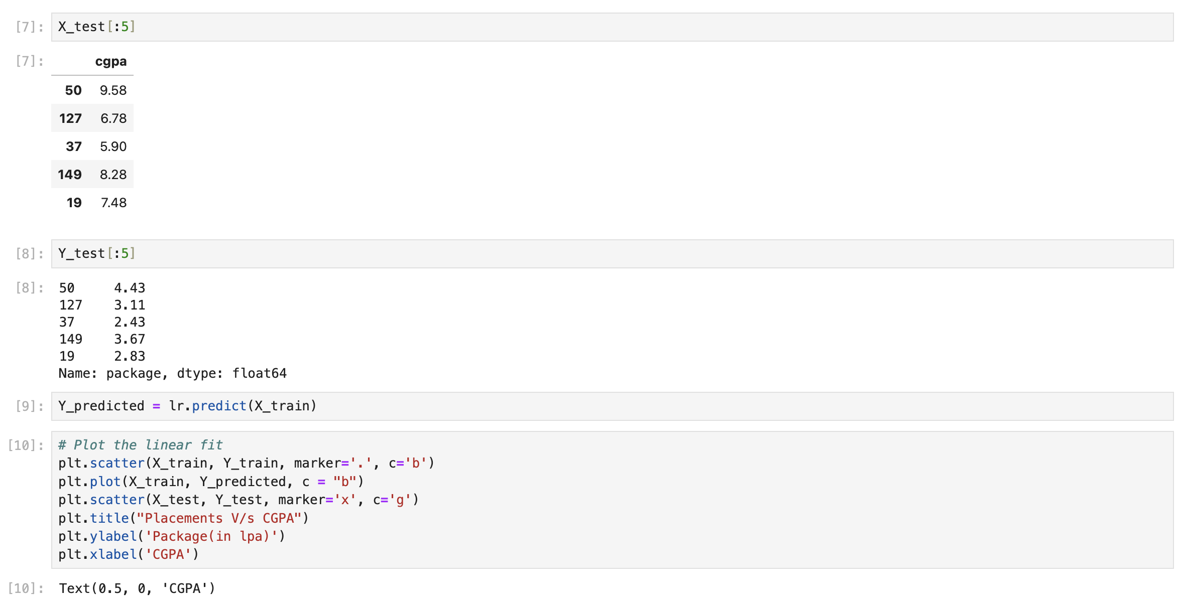

## 

**b) Implementing linear regression on randomly generated dataset and evaluation of the regression model using R2 score.**

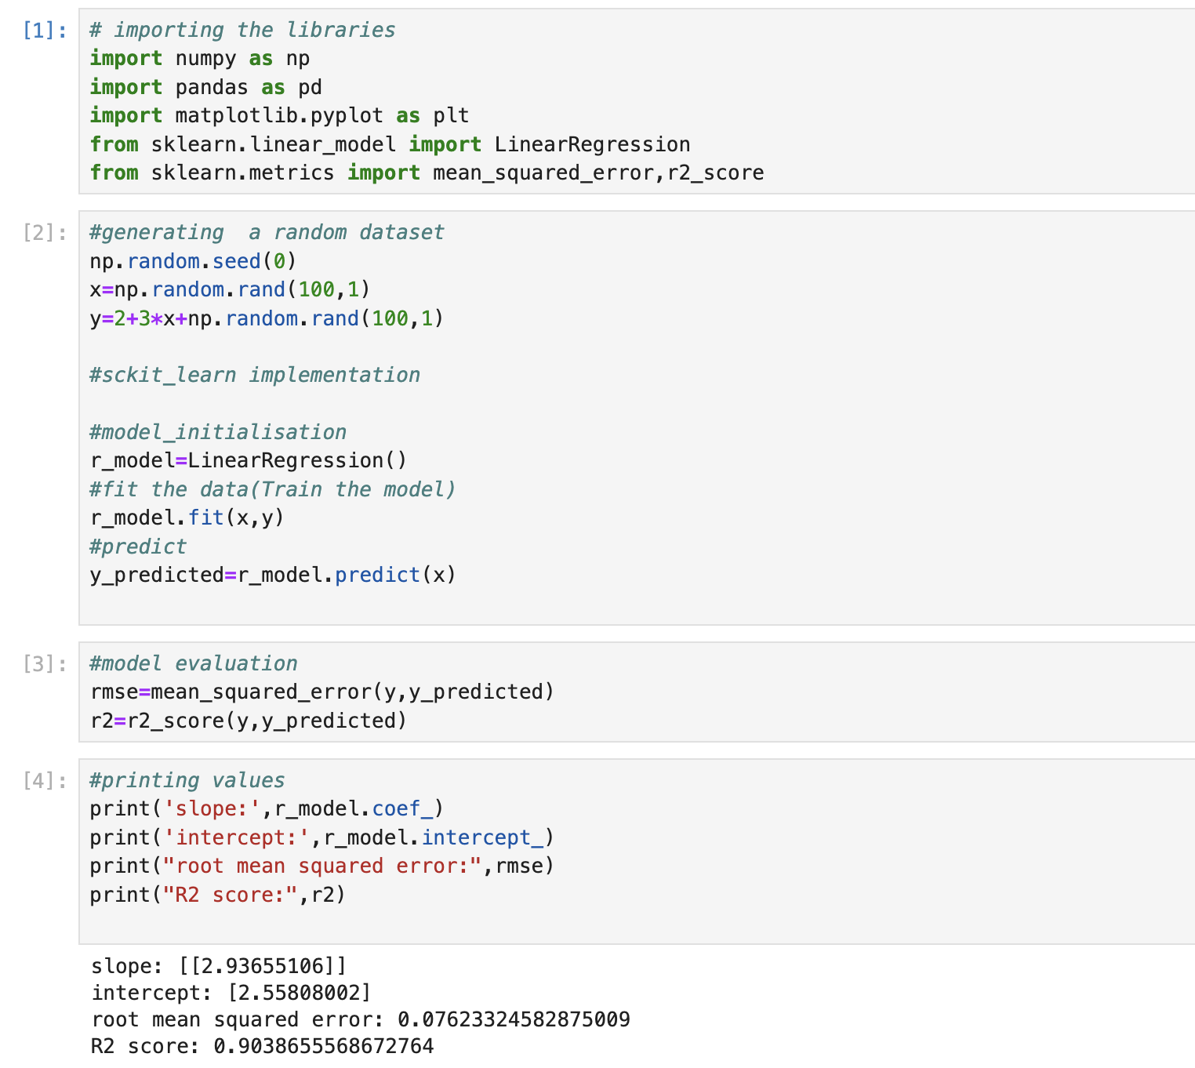

**2. Implementing and demonstrating the Find-S algorithm for finding most specific hypothesis.**

**3. Implementing Candidate Elimination algorithm and finding specific and general boundary sets of hypotheses consistent with EnjoySport dataset.**

**4.** **Implementing Perceptron learning from scratch and showing decision boundary.**

**5. Implementing classification using SVM :**

1. **For iris dataset using SVC default settings.**

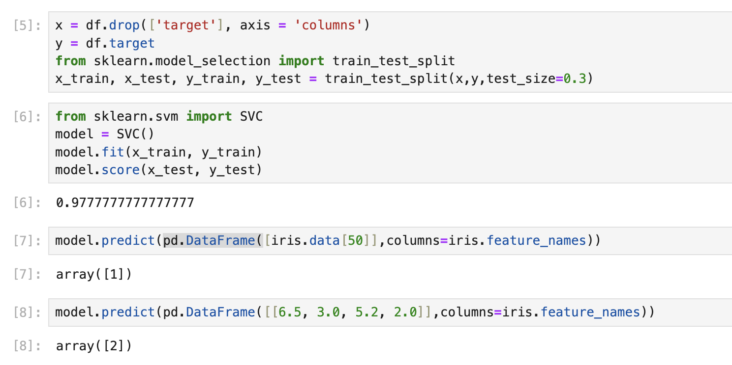

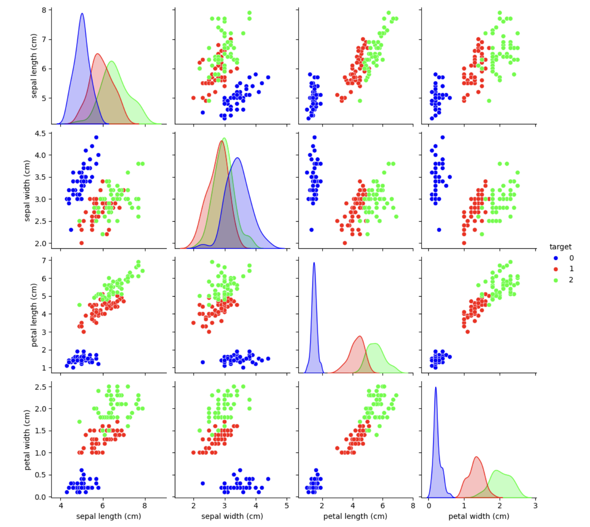

**b) For recognition of handwritten digits.**

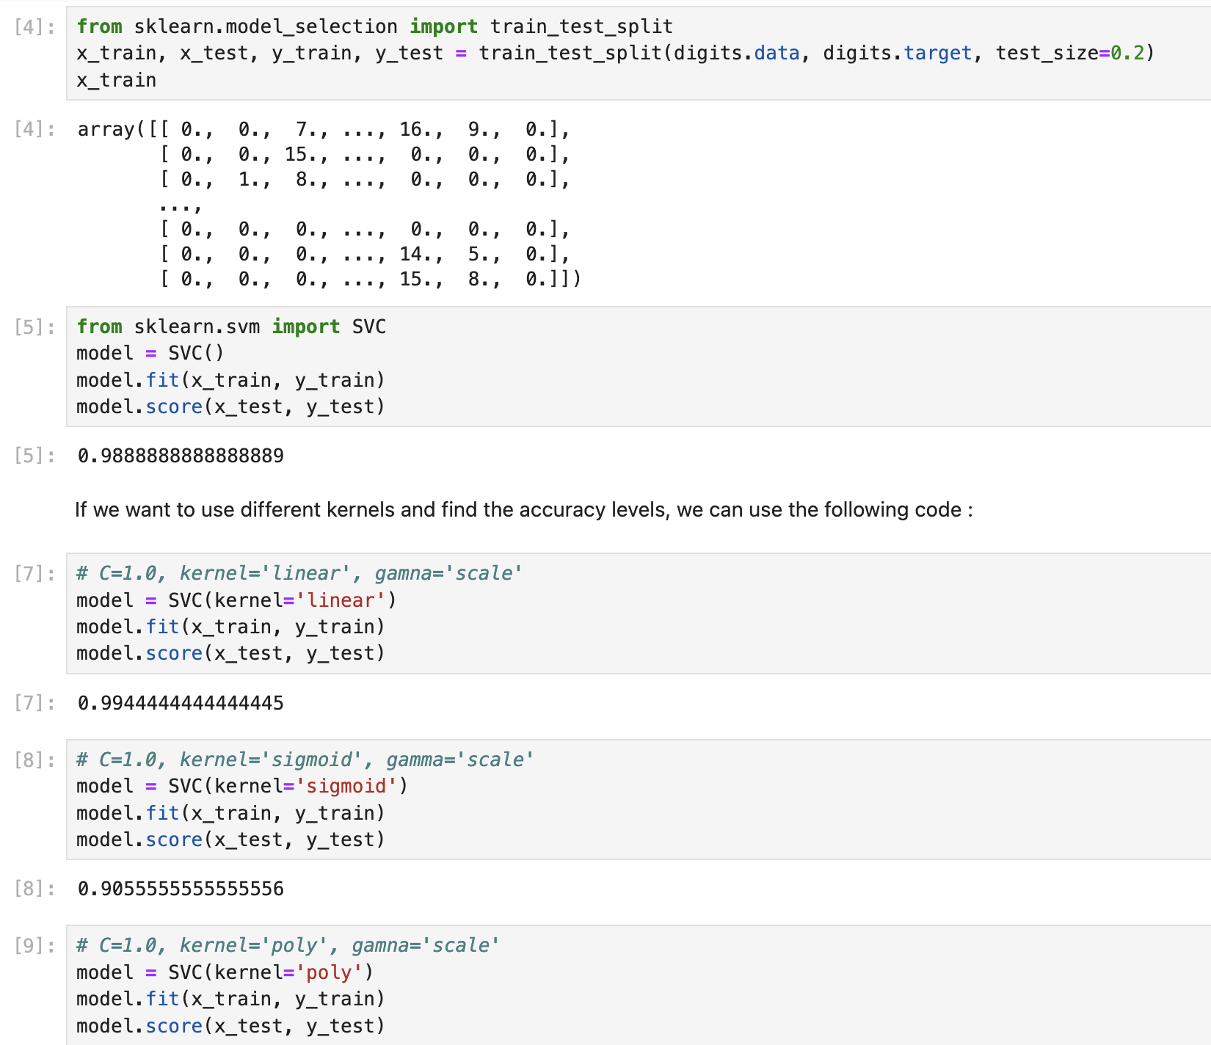

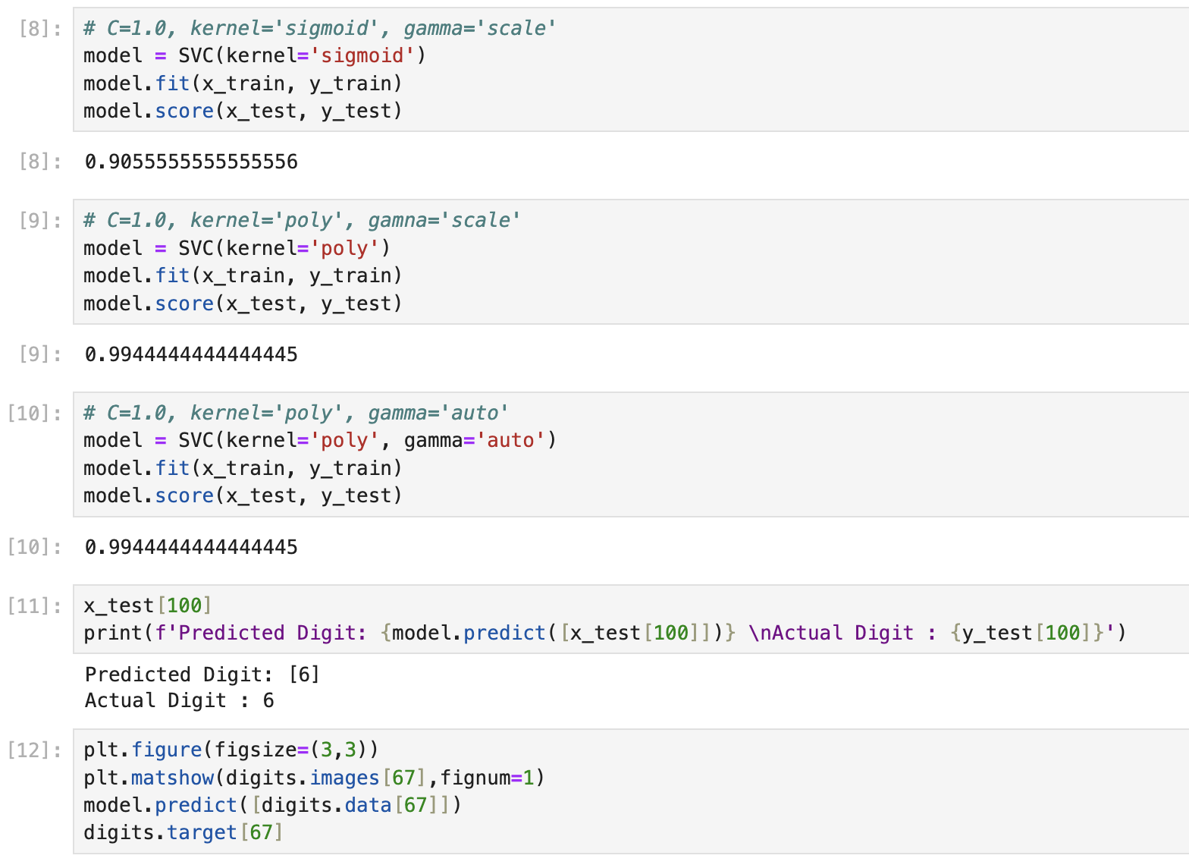

**6. Implement Naïve Bayes Classifier**

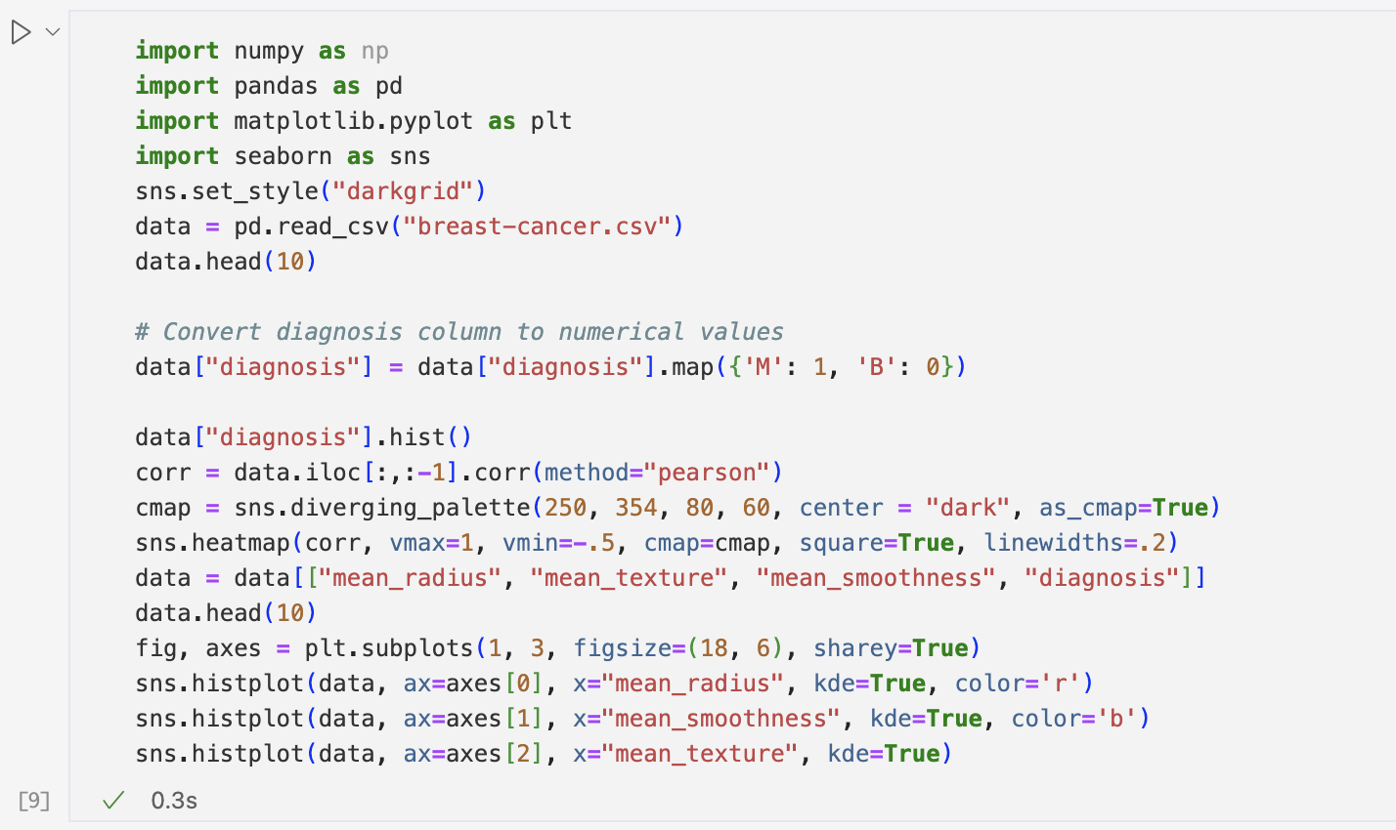

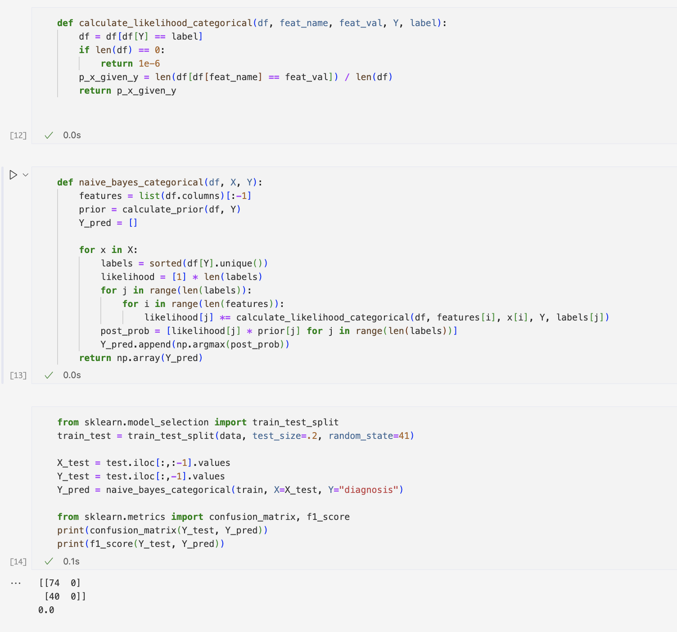

**7. Implementing PCA on Iris Dataset.**

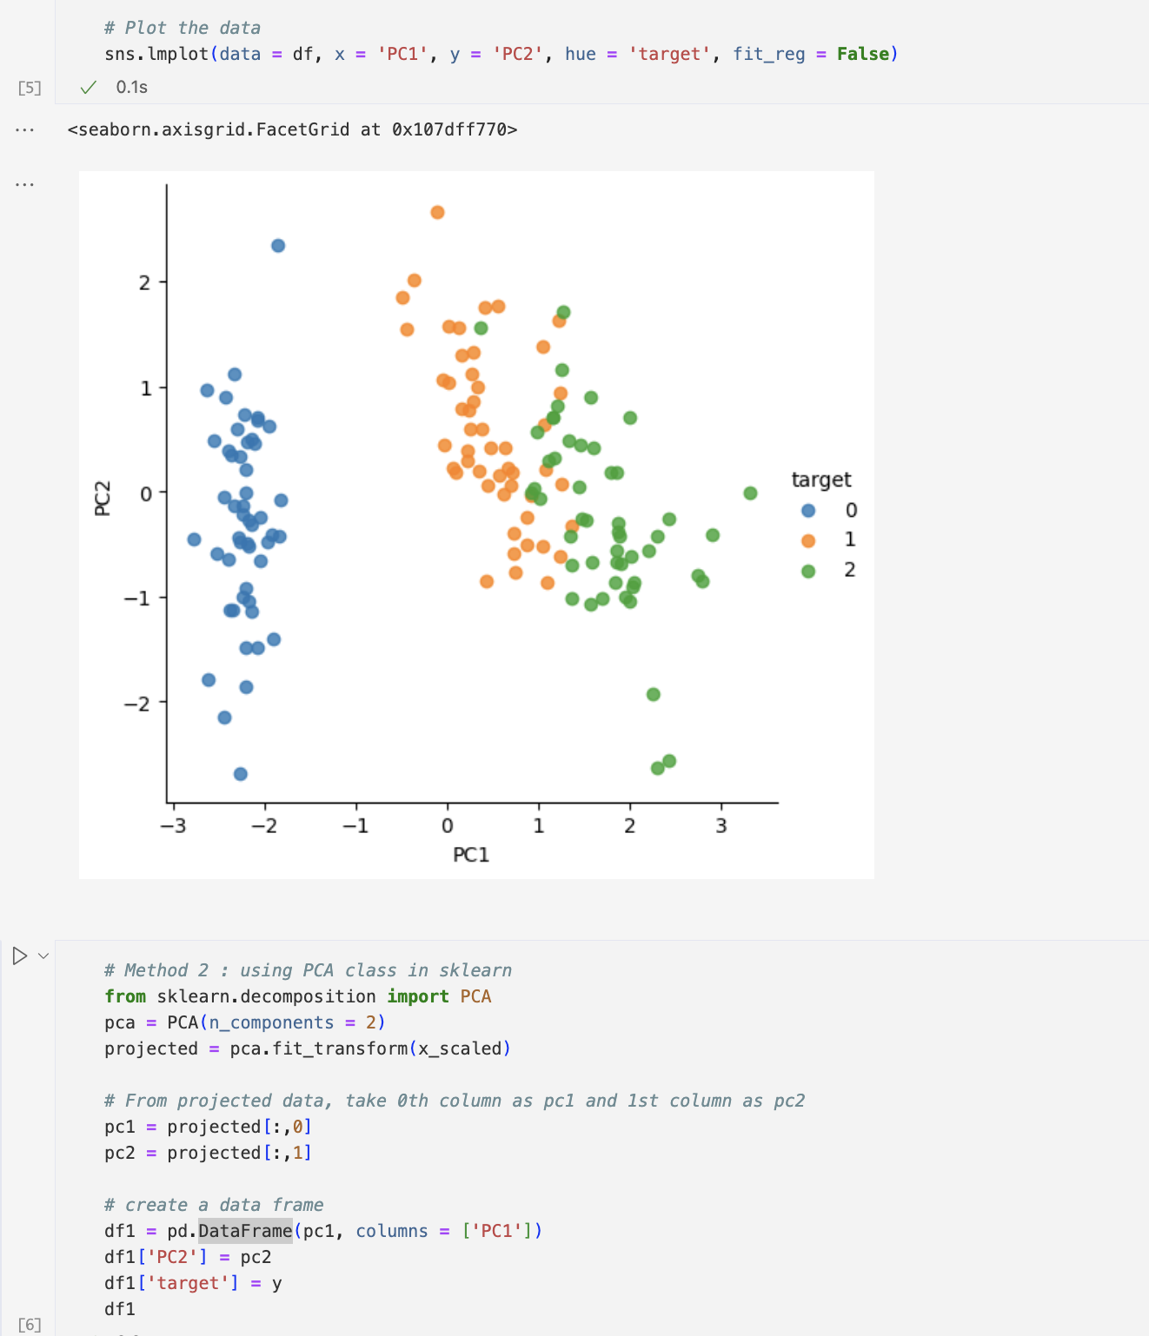

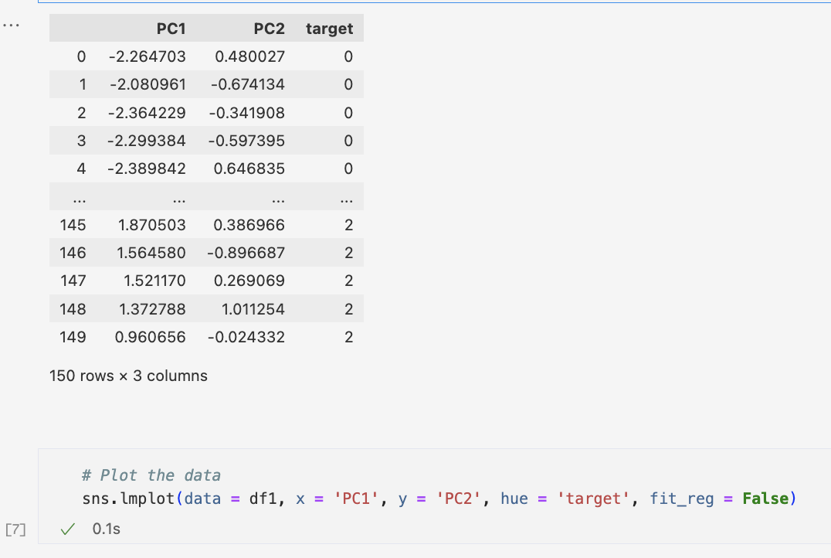

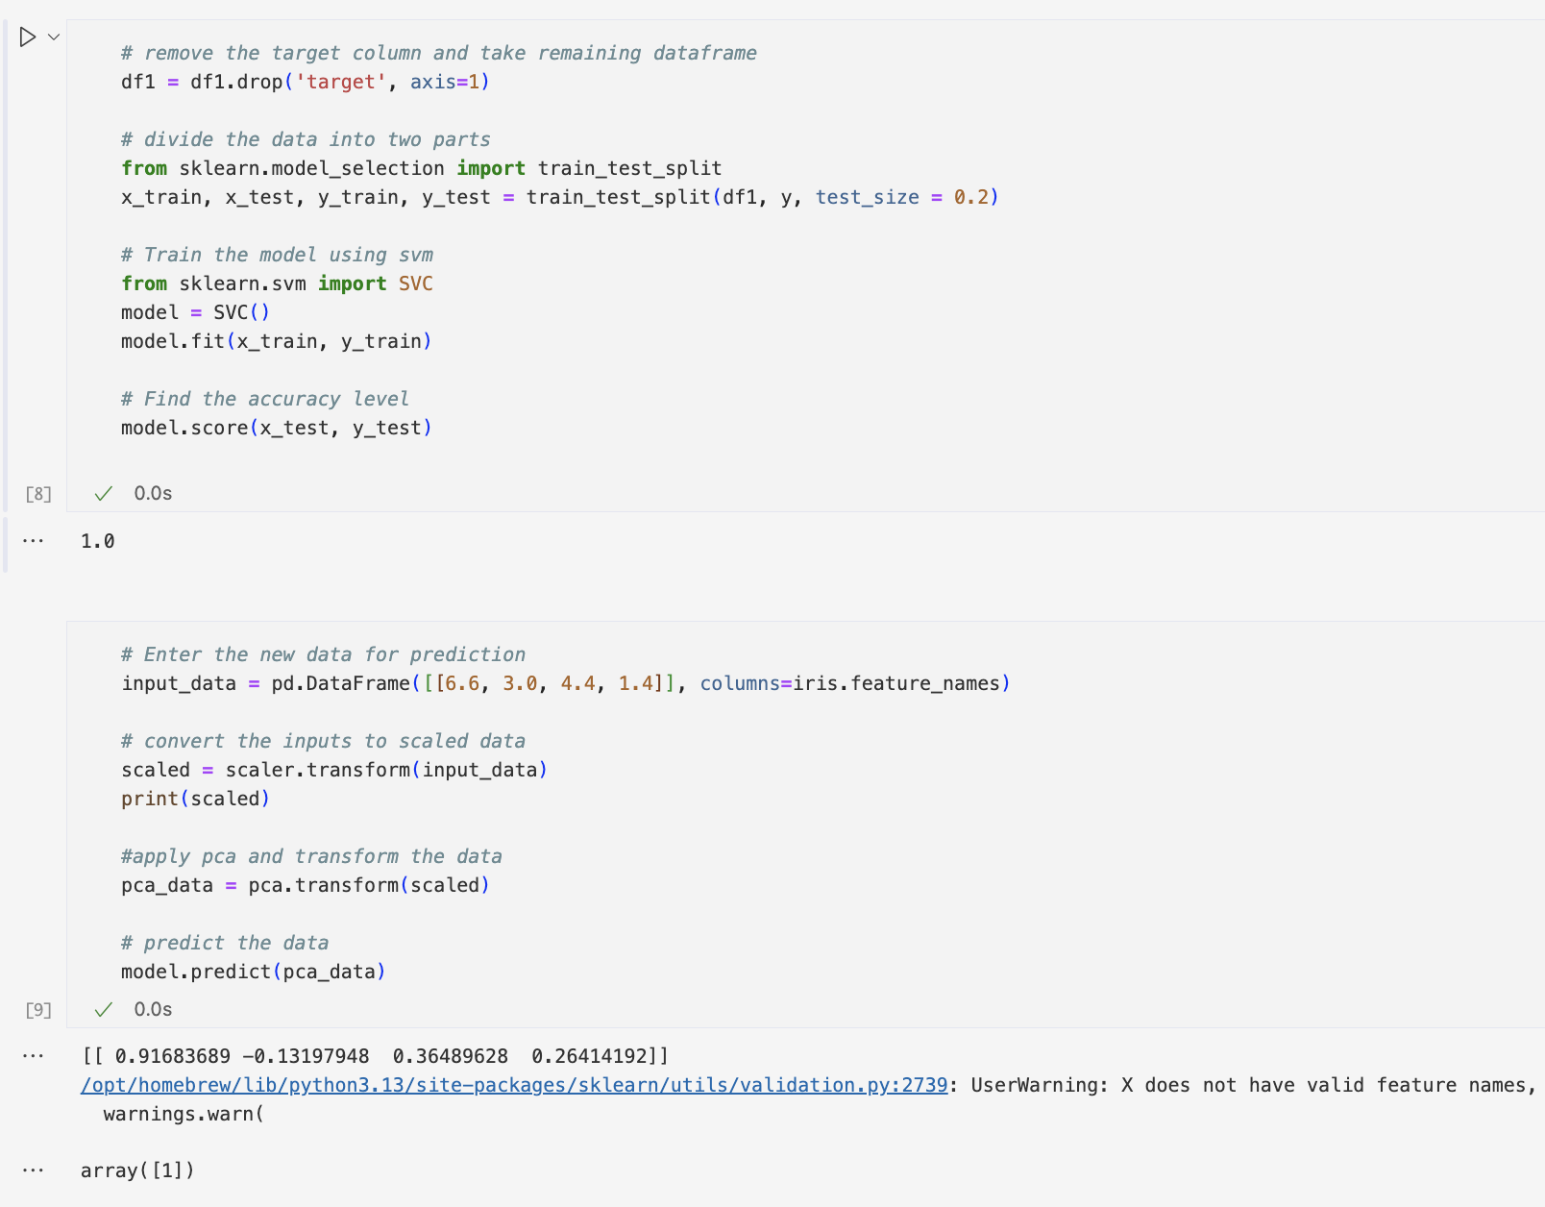

**8. Implementing Gradient Descent Algorithm**



